Type-C Dock Station
Multi Format Card Reader & Dual USB Hub
Designed for MacBook Pro, MacBook, and Windows Computers with Type C
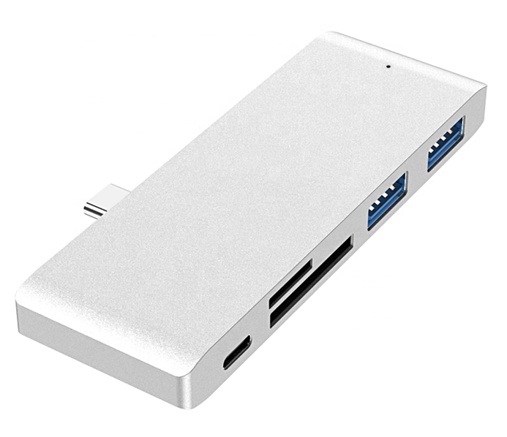

Descrption:
Ideal as a semi-permanent attachment to your MacBook(tm), MacBook Pro(tm) or other compatible Apple(tm) Notebook computer using the Type-C interface.
Simply plug into a vacant Type-C port on the Notebook and instantly use the devices integral dual USB3.0 interfaces for attached storage, printers, USB Hub extensions - almost anything.
Also included is a multi-functional memory card read/writer allowing super-fast access to the most popular card formats including SD(tm)HC, SD(tm), SDXC(tm), MicroSD(tm), MicroSDHC(tm), MicroSDXC(tm).
An integral Type-C charge port is also included, so you won't loose any Type-C ports on your Mac(tm).
Stylish in design, alloy construction which perfectly matches the styles of your Apple(tm) MacBook(tm).

Features:
- Type-C、USB3.0*2、 TF/SD 5 in1 Adapter Solve the problem of less external interface of notebook computer
- Relative to dual Type-C, it can only connect to Apple Macbook Pro/Air Single Type-C adapts to more brands of computers
- USB3.0 Data transmission can reach 5Gbps
- Supporting Large File Transfer on Camera Memory Card Fast Reading TF/SD Card Make Data Processing More Efficient
- Two Standard USB 3.0 Interfaces Connecting multiple USB devices such as mouse, disk, etc. Large file fast transmission, transmission speed up to 5 Gbps
- It is made of fine sandblasted aluminium alloy. Efficient heat dissipation, shielding interference durability, anti- oxidation.
- Delicate and easy to carry, Environmental protection and durability It's more convenient to go out to work
- Perfect fit, More intimate,gapless, For Macbook Pro tailor-made, the gap is controlled, within 1 mm,the interface is firm and not easy to loosen,intimate "infinite" can tacit cooperation.

- Application: MacBook, Dell XPS ,Samsung Galaxy, Huawei Mate

Specifications
- Material: Alumiunm Alloy
- Interface: 2* USB 3.0 2*USB2.0 1*PD3.0
- Color: Space Gray
- Transfer Port : USB 3.0
- Function: Charging+Data Transfer
- Certificate: CE FCC ROHS
- Operating Temperature:0℃ to +45℃
- Operating Humidity:10%0 to 85 % RH
- Storage Temperature : -10℃ to +55℃
- Storage Humidity: 5% to 90 % RH

Product Code:
Part number: C-TC-DS4-USB3
Barcode: 8400800039705
Size: 95mm x 34mm x 10mm
Weight: 90G

